**PROTECT MY BUBBLE**

*By: Kevin Nguyen, Ahoura Niknam,Marc Geis, Mike Yoon,Dung Ly*

**Team Name:** KAMML

**Github:** https://github.com/nguye304/ProtectMyBubble.git

**Project Roles:**

* Marc Geis
  + UI
  + GUI
  + Game Designer
* Kevin Nguyen
  + Game designer/story teller
  + Game manager
  + 3D modeler
* Dung Ly:
  + Game Programmer
  + Level Editor.
* Mike Yoon
  + Game Designer
  + Game Programmer
  + Level Editor
* Ahoura Niknam
  + Game Programmer
  + Level Editor
  + Logger

**High Concept Document**

**High Concept**

The Bubble space station has been attacked by alien invaders. Protect the station at all cost. If the space station falls, humanity will lose its only influence in the final frontier. Equipped with the best weapon technology the universe has to offer, protect the space station and Put those invaders in their place.

**Story Overview**

The Bubble space station is the pinnacle of human architecture and human engineering. It was the first architectural achievement done with the entire human race’s cooperation. It has the ability to mine an entire planet’s resources in a matter of hours. The Bubble space station stands as the strongest and most dominant force in space. Alien races across the universe tremble in fear of the Bubble space station and many hope to live without ever encountering it. However the brave Alien invaders called the Alients have had enough, and are invading in hope of gaining control of the station for themselves. Their strategies and actions are primitive and their technology is a few generations behind us but don’t underestimate their strength in numbers. The Bubble space station must stay in human control. Defeat the invaders by setting up your weapon defenses and holding out until reinforcements arrive.

**Features**

·The main goal of our game is to defense our space station from alien invaders. Before the level, the player will be asked set up weapon defenses to protect the space station from the attacking Alients. The player will only be given a set amount of resources that they can spend per level and must plan accordingly in order to protect the space station. There will be many different types of Alients

o The General Alients

o The Brute Alients

o The common Alients

o The special Alients

·Simple mouse controls will be implemented for the game. Once the player uses the mouse to set up the defenses of the space station, they will be able to shoot their own special abilities from the main space station.

·In the earlier levels, the power of weaponry and amount of resources provided to the player will be lower. As the user reaches higher levels, the power of the weaponry will improve since technology is always improving.

·In the earlier levels, the health and defenses of the Alient invaders will be a lot lower. As the levels progress, the Alient invaders will see that they will have to send in stronger, more powerful troops to try and take care of the invasion.

·The Alients will follow a route to the space station. This route will be shown to the player and the player will place their defenses around the route

**Player Motivation**

· The player wants to protect the human race from invaders. Since we are all humans we should want what is best for the human race. After a history of struggle and division, the human race is finally united as one and are finally proud to call themselves as Earthians.

· If the alien invaders are successful in the takeover of the Bubble space station, the symbol of human unity and ability will be stolen and used against them. The player should be motivated to help the human race stay together.

· The player will be motivated to discover new and power technologies available to them to defend the space station

· The player will be motivated to see the Alient bosses and the different types of alien forces that will be trying their best to invade the space station

· The player will be motivated by patriotism because they should love their race and their planet. Keep our great planet on the top of the food chain even in the final frontier

· These savage Alients are trying to overthrow our power on the universe. Quell their rebellion and insubordination through the use of superior intelligence, strategy and technology.

· The greed and lust for power of the Alients should motivate the player to eliminate the aliens and protect the space station.

**Genre**

This game is a science fiction space invader tower-defense game.

**Target Customer**

Our target customer is any strategy space science fiction genre tower defense loving gamer regardless of age. We want players to feel pride in who they are and give them the chance to protect the human race from alien invaders. The easy to use and understand gameplay will appeal to all ages. What will draw in this type of customer is:

· Fun and satisfying gameplay

· Players will be provided better and cooler weapons with level progression

· There are many different types of scary and cool looking aliens for the player to defeat

· Strategy based gameplay

· Interesting story of human domination

**Competition**

Protect my Bubble is a tower defense game set in space. There is a lot of competition for the tower defense genre. Big competitors will include Plants vs Zombies, GemCraft. Games like Starcraft and other games will have relatable art styles.

**Unique Selling Points**

· Our game will allow the feeling and enjoyment of being on the more dominant side of a war. While other games will usually support the resistance against an oppressive power, this game will be from the point of view of the oppressive power, since it is the human race in this situation. We want players to understand that when you’re at the top , you have to defend yourself and make sure you are able to survive.

The user interface will allow:

o Simple and easy to understand controls

o Clear and easy to navigate buttons (restart, quit)

o Menu will be easy to access

**Target Hardware**

Computer (Windows, Mac) with a mouse and keyboard

**Design Goals**

* The goal of our game is to keep the gameplay fun and satisfying. We want the game to have a more retro space kind of feel so with that in mind we want to keep it colorful and interesting.
* The tools that will be used include Unity, Maya , Photoshop and sound recording tools
* Within unity we will access the asset store for free assets in order to help make the game look better
* Program/UI specific goals:

o Health bar of castle will be visible at all times

o Health bar of weapon defenses will be visible at all times

o Players will be able to assign a defense to a tile easily

o Players will see a grid during the set up phase of the game

o Players will not see grid when the enemy attacks

o Players will be able to keep track of resources

* Cost of defenses
* Amount of resources provided
* Amount of resources left
* Game options menu that sends to main menu
* Main menu contains:

· Restart

· Quit

· Other options

· Our goal is to allow the player to experience at least a boss battle and some special Alient units. Also to provide the player with different types of weapon defenses.

**Game Treatment Document**

Protect My Bubble

Created By: Kevin Nguyen, Marc Geis, Dung Ly , Mike Yoon, Ahoura Niknam

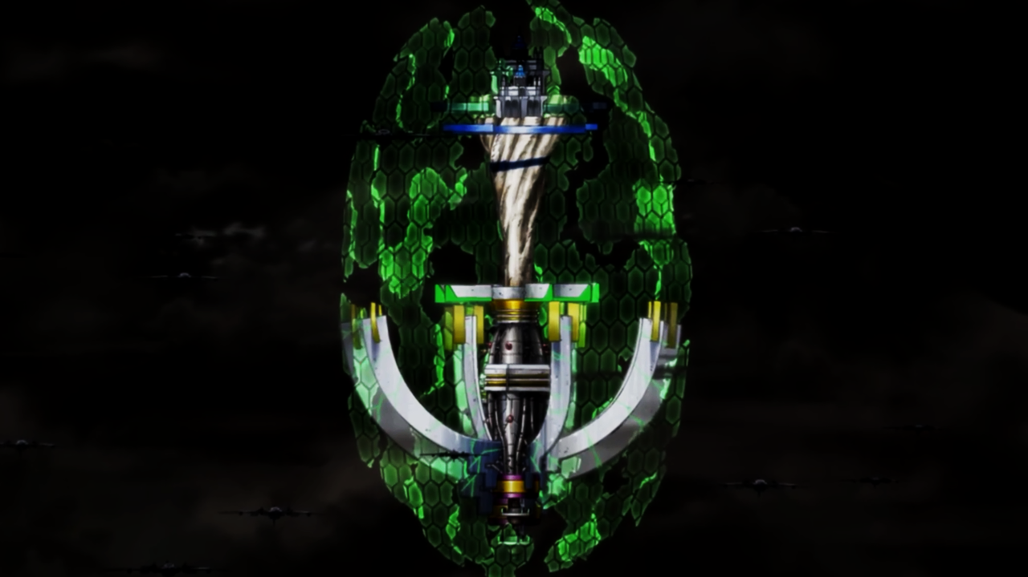

**Executive Summary**

· Protect My Bubble is a 3D, 3rd person, sci-fi genre tower defense game following the story of the Alient’s invasion of the Bubble space station

·Target audience is any sci-fi loving kids or adults with an interesting story and fun strategic gameplay

·Target hardware is low to medium range PCs. Any computer with a mouse and keyboard should be able to run this game.

·This game draws inspiration from other tower defense games such as Gemcraft and space games such as Starcraft and Geometry wars

·Unique art style and design with original models crafted from Maya

·Animations and noises that will make the gameplay more compelling and interesting

·Colorful and lot of stuff happening provide and exciting experience

·3D world that will allow the player to set up defenses before each level

·Development tools such as Unity and Maya will be used to create the game

**Game Overview**

**·Characters**

o The Bubble space station is the main goal of the game. We must defend the ultimate display of human ability from greedy alien invaders.

o Alients: the main antagonists of the game, who are alien invaders trying to takeover the Bubble space station

·**Setting**

o The game is set in outer space in a universe where humans have gotten past their differences and worked together in order to develop the ultimate space station. The space station has the ability to mine all the resources of planets in a matter of hours and is the ultimate force in the universe. Aliens tremble and fear and hope not to encounter the human race. However one foolish alien race called the Aliens have decided that they want the power for themselves and have challenged the human race.

·**Core Gameplay**

oPlayer will set up the Bubble space station’s defenses that will protect the space station from waves of Alien invaders. Once the level starts, the user will be able to place more defenses as long as they have the resources. The player will also be able to use special abilities special to the Bubble space station.

·**Main Theme**

o The theme of the game is one of overwhelming power and dominance. The player will defend the space station and show all alien races not to mess with humans.

**High Concept**

The Bubble space station has been attacked by alien invaders. Protect the station at all cost. If the space station falls, humanity will lose its only influence in the final frontier. Equipped with the best weapon technology the universe has to over protect the space station and Put those invaders in their place.

**Genre**

This is a 3D sci-fi tower defense game. Throughout the game, the player will be given a set amount of resources that they will use to build defenses for the space station. Their placement of defenses will determine whether or not they can protect the space station from the invading alien forces. Level progression will motivate the player since it allows new weapons and new enemies.

**Hooks**

The game will feature fun and strategic gameplay. It will contain multiple levels with rising difficulties which will give the player more opportunities to show their strategic abilities. With higher levels, the player will encounter interesting new enemies and will be able to use better and more advanced weapons. This game will provide players with the ability to use their brains and then watch as their plans come into play. The game will include interesting and fun sounds and graphics to keep the gameplay interesting and satisfying.

**Gameplay Highlights**

As the player progresses through the levels, they will receive more resources and more weapon upgrades that they will be able to use on their setup phase. The player will place their desired amount of defenses on the map and have to make sure to manage their resources correctly. After the setup of the defenses, the player will watch the waves of enemies try and attack the space station and hopefully they will be defeated by the defenses that were set up. If not , the player will have to try again and rethink their strategy and allocation of resources.

**Technology Highlights**

* Unity3D will be used to create the majority of this project since the engine allows for the development of 3D games with ease. The focused platform will be PC/MAC.
* For animation and 3D art design, we will be using Maya and Blender to sculpt and design the models we use in the game. These programs are both free and powerful enough to satisfy the requirements of our game. We will use this to make both environment models as well as the models of the weaponry and Alients.
* For any conceptual art and 2d elements, we have decided to use photoshop and paint.
* We will also be using Git and Github for version control since it was part of the requirements of the game project.

**Art and Audio Highlights**

* Protect My Bubble will feature some sounds from the free Unity asset store as well as some original sounds developed by the group.

**Hardware**

PC/MAC

**Production**

Development Team

* Kevin Nguyen
  + Game designer, 3D modeler, Game Programmer, writer, level editor
* Marc Geis
  + UI, GUI, Game Designer
* Dung Ly
  + Game Programmer, Level editor
* Mike Yoon
  + Game Designer,Game Programmer, Level editor
* Ahoura Niknam
  + Game Programmer, Level editor

**Budget**

The overall budget of this project is zero. All tools and all assets will be accessible and free to students. Nothing is paid for. The major expense for this project will be time and effort since many students will be developing this game while enrolled in other classes.

**Tentative Schedule**

1. Storyboard Completion
2. Character concept art design
3. Resources and gameplay design
4. Level concepts completion
5. Level Design
6. Level development
7. Repeat steps 3 - 6 until at least 5 levels.
8. Testing/Debugging
9. Demos

**Competition**

Protect My Bubble will be in competition with games such as tower defense, gemcraft and plants vs zombies. These games are also tower defense type games with new enemies and upgrades design for either PC , console or mobile.

**Characters**

oThe Bubble space station is the main goal of the game. We must defend the ultimate display of human ability from greedy alien invaders.

oAlients: the main antagonists of the game, who are alien invaders trying to takeover the Bubble space station

**Setting/Story**

o The game is set in outer space in a universe where humans have gotten past their differences and worked together in order to develop the ultimate space station. The space station has the ability to mine all the resources of planets in a matter of hours and is the ultimate force in the universe. Aliens tremble and fear and hope not to encounter the human race. However one foolish alien race called the Alients have decided that they want the power for themselves and have challenged the human race.

**Success/Failure**

The game will be level based so failure will simply mean the space station is destroyed and the player will have to restart the level and try again. Success will mean that the player will be able to move onto the next level and unlock better weapon upgrades and fight against stronger enemies.

CS485 Game Proposal

<https://docs.google.com/presentation/d/1RieCymmkERBD2JoxcH_vU8IDX1XaaXT81VknHyTtjWA/edit?usp=sharing>

The Discord: https://discord.gg/826ZPYu

Discord Tag: Kevin#4455

Email used: [kevin.nguyen38@yahoo.com](mailto:kevin.nguyen38@yahoo.com)

Discord Tag: Marc#1553

Discord Tag: Yoonster#7846 (Mike)

---------------------------------------------------------------------------------------------------------------------Resources

Tower Defense Game

Tutorial - <https://unity3d.com/learn/tutorials/projects/tower-defense-template/introduction-tower-defense-template>

https://assetstore.unity.com/packages/essentials/tutorial-projects/tower-defense-template-107692

How to - <https://www.youtube.com/watch?v=beuoNuK2tbk>

Theory - <https://www.raywenderlich.com/168079/create-tower-defense-game-unity-part-1-2>

### Final Fantasy Game

RPG Build - <https://www.youtube.com/watch?v=l4Hijtk4NDc&list=PLZ1b66Z1KFKgp-sjQ8ldU3eh8DoQ3a14P>

JRPG Theory - <https://gamedevelopment.tutsplus.com/articles/how-to-build-a-jrpg-a-primer-for-game-developers--gamedev-6676>

Graphical Theory Tutorials - <https://unitytutorials.ca/graphics>

Turn-Based Combat <https://www.youtube.com/watch?v=Uhnh8zj_VPo>

### Platformer

2d Side Scroller - <https://www.youtube.com/watch?v=BdlL5bwbCiI>

Basic Platformer - <https://unity3d.com/learn/tutorials/topics/2d-game-creation/creating-basic-platformer-game>